Benefits of oatmeal
Student’s name
Institution affiliation

Executive Summary (*3) (10 marks)
Oatmeal is basically foods that are taken as breakfast since they are light foods. Also, Oatmeal's are healthy foods that impact our health positively. For instance, Oatmeal's are highly nutritious; also, whole Oatmeal is rich in Antioxidants, Oatmeal contains a strong soluble fiber known as the Beta-Glucan, and finally, Oatmeal improve the health of the body by maintaining the required level of blood sugar.

• Introduction/description of Process (*4) (5 marks)
Introduction.
Oatmeal falls under the category of healthy meals that may contribute to reducing obesity among individuals. Most of the Oatmeal is taken during breakfast since they are light foods. In addition to Oatmeal, it's a very healthy meal that gets one's motor functioning throughout the day if undertaken by an individual as well as it can be a very delicious meal if made well (Mackie et al., 2017). Oatmeal is positively associated with significant benefits. Such benefits of consuming or taking Oatmeal as a breakfast include- Oatmeal is highly nutritious; also whole Oatmeal is rich in Antioxidants, Oatmeal contains a strong soluble fiber known as the Beta-Glucan, Oatmeal improve the health of the body by maintaining the required level of blood sugar, and finally Oatmeal aids people who have issues associated with obesity lose their weight. Consumption of Oatmeal aids in reducing the risks of heart diseases that have become more prone to peoples.
In order to develop a basic recipe for cooking Oatmeal, one has to be fully equipped with various tools that will enable one to progress smoothly without difficulties. Therefore, all the requirements one needs in order to come up with his or her own Oatmeal, especially at the homestead, include the Oatmeal itself, the salt and sugar in case one wants to make the Oatmeal sweet, and finally bags that sealable for storing the Oatmeal (Wack, 2018). The primary purpose served by salt is to enhance flavor among foods. Thus the use of salt in the cooking or preparation of Oatmeal tends to bring out the inherent but subtle sweetness and nuttiness of the oat. In the Oatmeal preparation, it is always advisable to only add low-calorie sweeteners or a small amount of sugar, considering that the use of more-calorie sweeteners such as honey significantly contributes to raising the blood glucose level within one's body.
The Process of preparing the Oatmeal is easy. Such a procedure of preparing Oatmeal commences by adding some amount of Oats to the sealable bag, preferably a quarter of a cup. The next step is taking some salt, preferably one teaspoon, and putting it in a separate bag with the Oats (Lee et al., 2018). The other step entails pre-adding a small quantity of sugar, preferably of about half a teaspoon, to enhance the Oatmeal's sweetness. Adding sugar depends on the individual preparing the Oatmeal since one can choose to add some amount of sugar or none. After preparing the Oatmeal, one can either flavor it or not.
• Analysis Tools (15 marks)
o Flow diagram
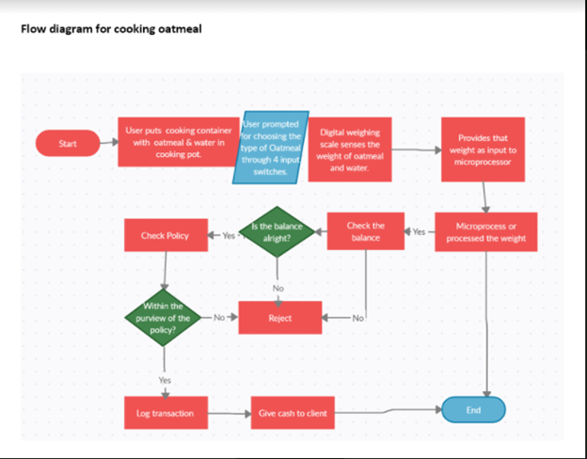
o Operations Process Chart

o Process Flow Chart
Right hand |  | Left hand
Cooking | Operation | seasoning
Getting the product from a shop | Transportation | Purchasing of salt  Taking salt from its package
Checking the salt added | inspection | Tasting the meal
Time taken to cook | Delay | Response of heat
Storing the exta | storage | Serving the meal

o Left Hand/ Right Hand
Action | Left hand side | Right hand side
Operation | 1 | 2
Transportation | 2 | 2
inspection | 3 | 1
delay | 1 | 3
storage | 2 | 1
total | 9 | 9

• Possible Improvements with Proposed Process (10 marks)
The feeding process can be improved by utilizing the many different recipes for Oatmeal. The nutritional density varies according to the recipe followed; as a result, the health impact is different.
Is blending of the Oatmeal with other ingredients such as lemon improves the nutritional value and thereby making a positive impact on an individual's health.
Serving the Oatmeal at the right time is essential in building an individual's nutritional value. Being a grain meal, it provides the body with a lot of starch hence making its functional benefit be the active moments.
The development of a recipe for the cooking process can be evaluated on the outcome; hence additional characteristics rather than the usual ingredients can give a different taste of the same.
The consumption of this Oatmeal should be within a small time range to avoid infections associated with a prolonged period without consumption (Zyba et al., 2019). This can be embraced by ensuring that the amount prepared each day is just enough for the meal.
• Comments and Conclusion (10 marks)
Cooking is a value-adding process. It improves the taste, looks, and attractiveness of either raw or cooked ingredients. Oatmeal is one of the most recommendable breakfast meal. This is due to how fast it can be prepared, a simple and clear recipe, and finally, because it takes a short time to cook.
Oatmeal is very helpful to the digestion system as it contains fiber .this will ensure a good digestive system throughout the day.
Most people have a mentality of how cooking is a tiring and boring task, especially men. Such a simple process has proved the capability of individuals taking a healthy meal and living in simplicity as the meal is just a grain product. The consistency of consumption of this product forms the basis of the health impact. Little or no consistency has less or no impact on human health.

References
Zyba, S. J., Wegmüller, R., Woodhouse, L. R., Ceesay, K., Prentice, A. M., Brown, K. H., & Wessells, K. R. (2019). Effect of exogenous phytase added to small-quantity lipid-based nutrient supplements (SQ-LNS) on the fractional and total absorption of zinc from a millet-based porridge consumed with SQ-LNS in young Gambian children: a randomized controlled trial. The American Journal of Clinical Nutrition, 110(6), 1465-1475.

